Big Six

Instruction Manual

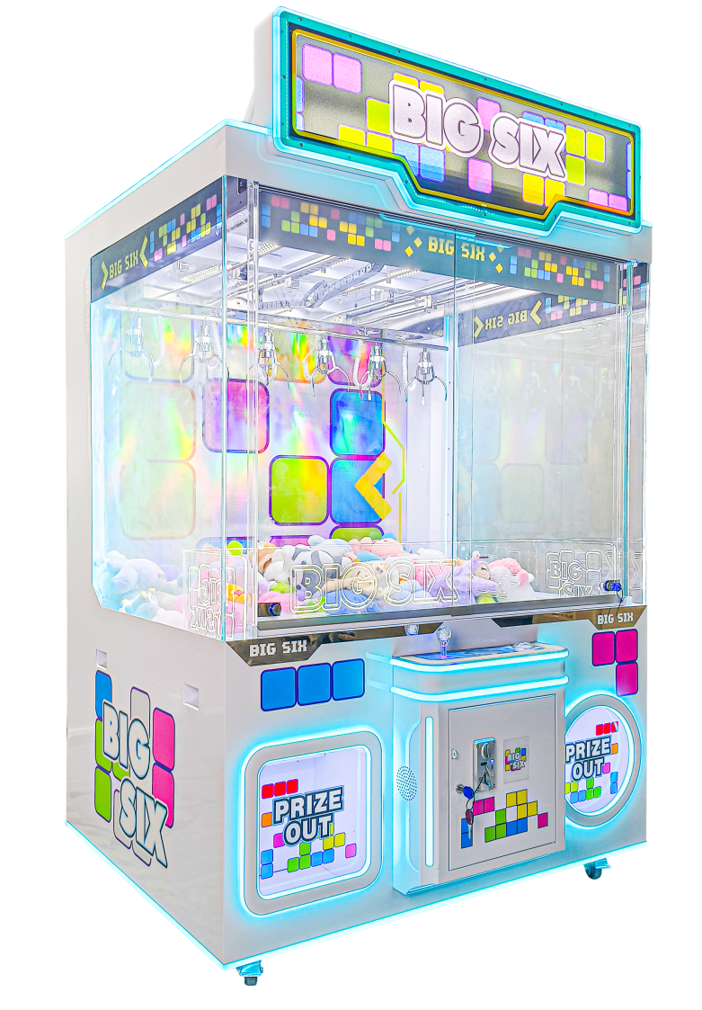

Please read this instruction carefully before installation and use

Contents

Instruction Manual 1
（1）Specifications and Technical Parameters 3
（2）Game play 4
（3）Main Menu 4
1.Revenue 4
2.Parameter 5
3.Payout Setting 5
4.Crane Setting 5
5.Machine Setting 7
6.Factory Setting 8
7. System settings 8
8. Return to the game 8
9.Fault prompts 8
10.Installation Tips 11
11.Wiring diagram 16

（1）Specifications and Technical Parameters

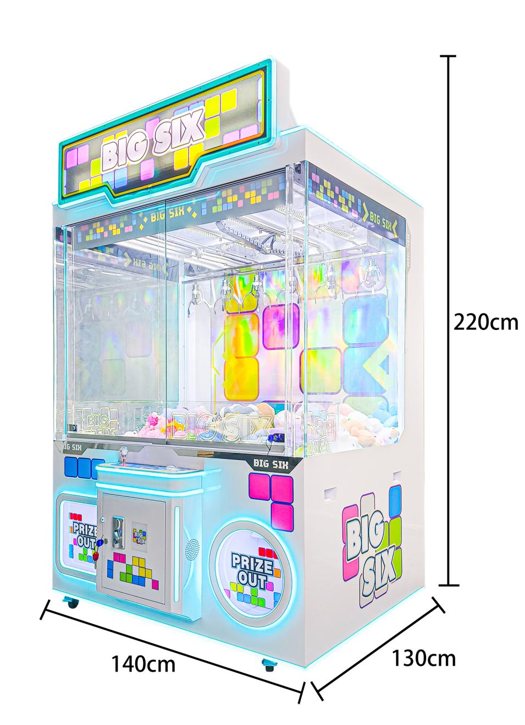

- Voltage: AC 220V - 240V, 50/60 Hz or AC110V±5%, 50/60 Hz
- Minimum power: 110W
- Maximum power: 920W
- Dimensions: W1450 × D1265 × H 2200 (mm)
- Weight: 295Kgs
- Game play

-Insert coins and use the joystick to control all six claws. Press the button to grab up to six prizes, and if you win, take them from the front prize door.

（3）Main Menu
-To enter settings: Turn on the machine and press the setup button for 1 second. Note: You cannot access settings during gameplay.

- Revenue
- Parameter
- Payout Setting
- Crane Setting
- Machine Setting
- Factory Setting
- System Setting
- Return to the Game
※Adjusting Parameters: Use the joystick to navigate the main menu and select the function to modify. Press the button to enter. Adjust parameters with the joystick and press the button to confirm and return to the previous menu.

-Below is a detailed explanation of each function and its settings:

1.Revenue
1--[Current bill]
Total coins: | Current total coins:
Total games: | Current total games:
Total prizes: | Current total prizes:
Prize claw 1: | Current prize claw 1:
Prize claw 2 | Current prize claw 2:
Prize claw 3: | Current prize claw 3:
Prize claw 4: | Current prize claw 4:
Prize claw 5: | Current prize claw 5:
Prize claw 6: | Current prize claw 6:

2--[Historical bill]
Total coins: | Historical coins:
Total games: | Historical total games:
Total prizes: | Historical total prizes:
Prize claw 1: | Historical prize claw 1:
Prize claw 2: | Historical prize claw 2:
Prize claw 3: | Historical prize claw 3:
Prize claw 4: | Historical prize claw 4:
Prize claw 5: | Historical prize claw 5:
Prize claw 6: | Historical prize claw 6:

2.Parameter
1.Coins/Game: How many coins to play one game. Range:1-30, Default: 2 coins
2.Plays/Game: How many times you can drop the claw per game. Range: 1-30, Default: 1 play
3.Game time: Range: 5-60s, Default: 30s
※Note: If the game time limit is exceeded, the claw will automatically lower to grab at time out.
- Music set: Range: 2-60 minutes, Default: ON
※Note: Sets the interval for background music.
- Shake Warning: [ON] or [OFF]， default setting: [OFF]
※ When the machine is shaken, the machine will report a shake warning, and the LCD will display: Do not shake the machine
- Payout Setting（Prize Setting)
- Bonus Claw: How many claws can catch prize in bonus game. Parameter range: 2-6,
default setting: 3
- Probability: How many games to give one prize. Parameter range: 1-999, default: 10
3.Game/Bonus: How many games for one bonus. Range: 2-999, Default: 50

Example:
Bonus Claw: 3 Game/Bonus: 50
Means at plays 50/100/150, 3 claws will go full power to try and catch prize, the other 3 claws will still be set at the standard power settings. The 3 claws on full will be randomly chosen.

Note: When the Probability or Game/Bonus condition is met, if no prize is captured, the number of claws that can catch the prize will be carried over to the next round and continue to accumulate until a prize is successfully captured.

4.Crane Setting
1. Move Speed: Parameter:50-100, default:60
※The larger the value, the faster the crane moves forward and backward.
- Lift Speed: Parameter:50-100, default:90
※The larger the value, the faster the claws rise and fall
- Bottom Time: Parameter:1-50, default:10
※The time the claw stays at the bottom. The larger the value, the longer the stay time.
4. Top Time: 0.1-5.0, default 1.0
※ The time the claw stays at the top. The larger the value, the longer the stay time
5. Move Delay: Parameter:0.1-1.0, default:0.2
※ The delay time of the crane start-up after moving the joystick, the larger the value, the longer the delay time
6. Claw #1-6 Power (Strength settings)
※ Move the joystick up and down to switch between different options, move the joystick left and right to adjust the claw force value, and press the console button to close the claws (you can put the doll on the claws and press the console button to see the claw force effect)
- Catch Power: Parameter:10-100, default:65
※The higher the value, the stronger the claw strength.
- Lift Power: Parameter:10-100, default:26
- Top Power: Parameter:10-100, default:17
- Payout Power: Parameter:10-100, default:86
- Test Power: default: 11, range: 10-70
※Machine settings-claw force during automatic testing

These parameters are an important parameter for the operation of the Big Six. This adjustment is subject to the actual situation, and product type in the game. These are only starting points and are the responsibility of the operator to refine the settings per their location.
※ Grip adjustment is a very important part of daily operation. The feel of grabbing items will directly affect the player's willingness to consume. Please refer to the following points before setting:
Name | Grip Strength Explanation | Grip Strength | Claw Force Parameters | Applicable Specifications
1 Catch Power | The strength of the claws to grab objects | Strong | 65 (default) | 4~6 inch doll
2 Lift Power | The strength of the claw rising to the highest point after grabbing the object | Middle | 26 (default) | 4~6 inch doll
3 Top Power | The strength of the claw returning to the origin after reaching the top | Weak | 17 (default) | 4~6 inch doll
4 Payout Power | Give this game a big grip, the strength of the claws throughout the game | Super Strong | 86 (default) | 4~6 inch doll

※ Description 1: The default claw force is generally based on 4-6 inch dolls as an example
※ Description 2: The actual gifts used are different. Please enter this function according to the actual situation, adjust the grip force automatically, and test repeatedly to select the best value.
※ Description 3: Under normal circumstances, the grip force setting is:
Payout Power>Catch Power>Lift Power>Top Power

※ Claw force parameter corresponding voltage reference table:

Claw Strength | Voltage(V)
100 | 47.2
90 | 46.8
80 | 42.2
70 | 37.6
60 | 33.0
50 | 28.4
40 | 23.8
30 | 19.2
20 | 14.8
10 | 10.2

Default claw strength parameters corresponding to voltage
Claw Strength | Voltage(V)
65 | 35
26 | 17
17 | 13
86 | 45

5. Machine Setting
- Auto Test
※Press button to confirm, it will start to test immediately and show the test times.
- Manual Test
※Manually move the joystick and press button to test.
- Sound Test
※Checks the speaker quality.
- Input Test
※Test the input signals of coin acceptor, bill acceptor, all buttons, joysticks, microswitch, and sensor.
- Output Test
※Tests output signals from the coin acceptor, digital counter, light control, claw drive, microswitch, and lifting mechanism.

6. Factory Setting
1. System Language: Chinese and English, default: English
2. Inhibit Coin: Prevents coin insertion when a fault occurs. Options: [ON] or [OFF]. Default: [ON].
3. Free Play: Optional [ON] or [OFF] Default: [OFF]
※If you select On, the machine can start the game without inserting coins.
- Factory Reset: Optional [ON] or [OFF] Default: [OFF]
※Using this function will reset all parameters to default values. Please reconfigure according to your needs.

7.System Setting

※View machine information.

8. Return to the Game
※Return to the game after selection.

9. Fault prompts
Gift sensor fault --------Check whether there is any foreign object blocking the sensor, or adjust the intensity of the sensor.
Test: Backstage-Machine Test-Input Test-Detection sensor #-Trigger the corresponding sensor, check whether the font of the corresponding detection sensor on the LCD turns red, if it turns red, it is normal.

Crane rear stop fault--------Backstage-Machine Test-Input Test-Crane rear limit-Trigger the corresponding microswitch, check whether the font of the crane rear limit on the LCD turns red, if it turns red, the microswitch is normal.

Crane front stop fault--------Backstage-Machine Test-Input Test-Crane front limit-Trigger the corresponding microswitch, check whether the font of the crane front limit on the LCD turns red, if it turns red, the microswitch is normal.

Crane upper stop fault--------Backstage-Machine Test-Input Test-Up Limit-Trigger the corresponding microswitch, check whether the font of the Up Limit on the LCD turns red, if it turns red, the microswitch is normal. If the time for the overhead crane to lower and retract the claw is too long, the crane will stop operating before the claw reaches the top, resulting in an error. The error can be solved by restarting.
Overhead crane down stop failure--------Backstage-Machine test-Input test-Down Limit-Trigger corresponding microswitch, check whether the font of the Down Limit on the LCD display turns red. If it turns red, the microswitch is normal.
Coin acceptor failure--------Switch the coin acceptor mode to the normally open NO mode, restart or press the repair button.
(Note: Under normal circumstances, the coin acceptor mode should be switched to the normally open NO mode.)
Warning:
Do not connect the terminal labeled "Dedicated for crane maintenance" to the JP12 terminal on the motherboard when the machine is operating normally and no fault is reported for the crane stop.
Note:
- When the crane stops down, the claw cannot be lowered and the repair key cannot be used to repair it:
You can unplug the JP12 terminal on the main board and connect the 24V terminal (with a “Dedicated for crane maintenance” label on the wire), and the claw can be lowered (no need to lower the claw to the bottom), plug the JP12 terminal back into the mainboard and restart the machine to fix the problem.
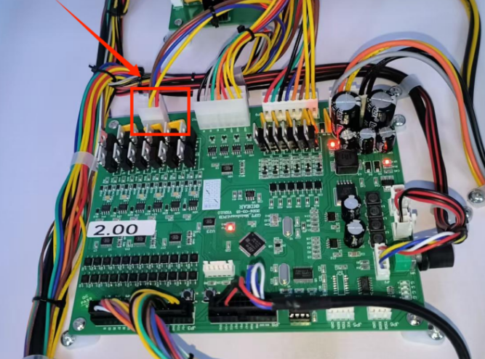

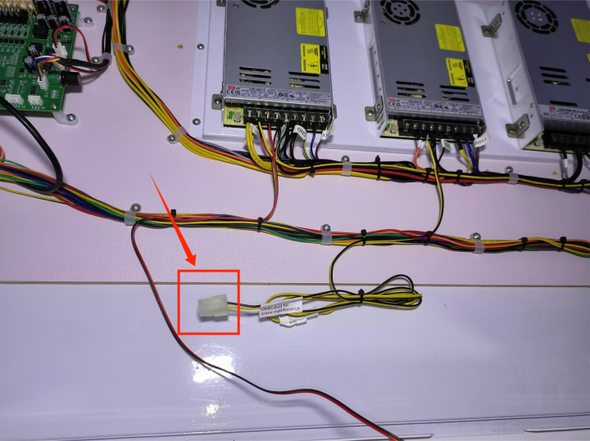

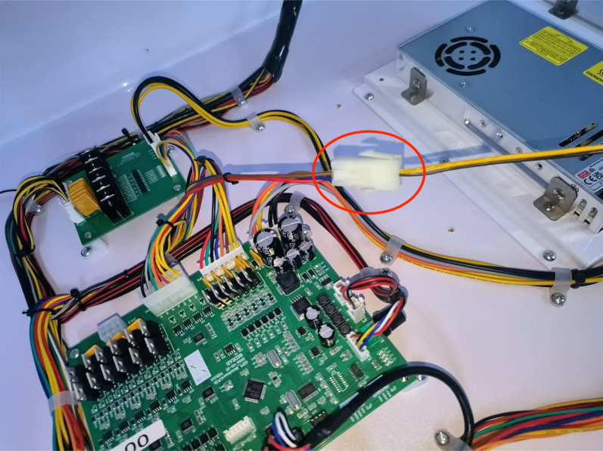

- Reversely plug the terminal on the wire with the label "Dedicated for crane maintenance" and connect it to the JP12 terminal on the main board to control the rise of the claw.

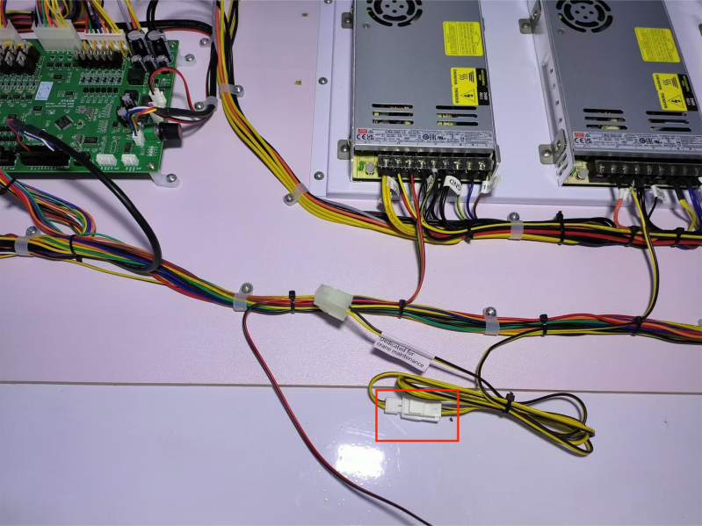

10.Installation Tips

How to install the overhead light box
- Remove the screws on both sides of the light box on the top of the machine. There are 2 screws on both sides. Remove all of them.

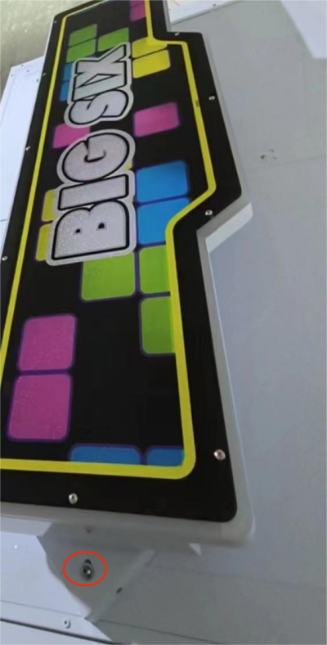

- Remove the fixed triangle brackets on both sides of the light box (remove the screws of the brackets on both sides), a total of 4

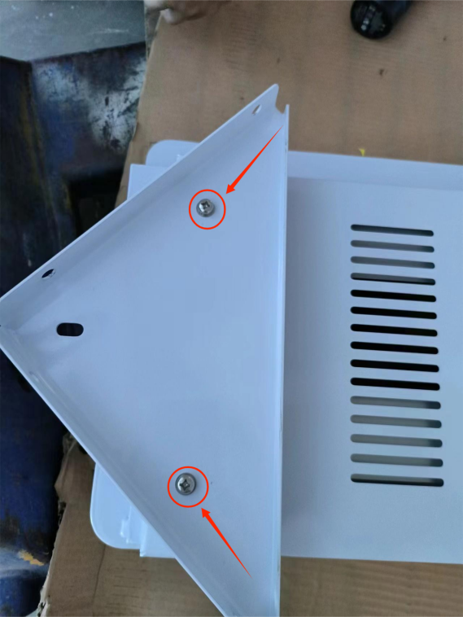
- Stand the removed fixed bracket upright and place it on the light box. Fix the screws of the brackets on both sides, a total of 4 screws (pay attention to the direction of the
- brackets, as shown in the figure below)

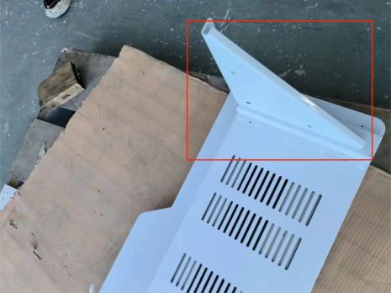
- Before installing the light box on the top of the machine, connect the light control wire. After connecting, plug the wire into the hole.

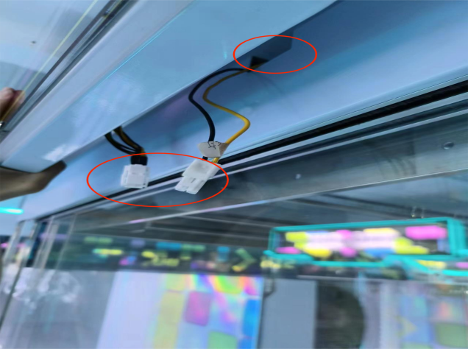

- Tighten the screws that fix the tripod brackets on both sides of the light box, a total of 4 screws

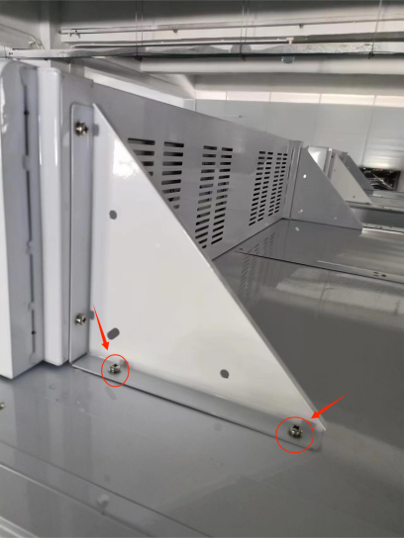

How to install the console (Note: For machines equipped with gift partitions, the console will be placed on top of the machine during packaging.)
- Open the console door, remove the two fixing screws inside, and then take out the console

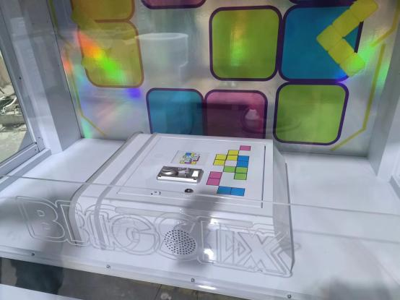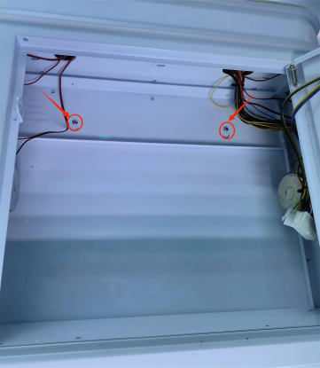
- Remove the hardware color plate of the console (there is hardware at the bottom of the color plate), and pass the sensor through the inside of the console.

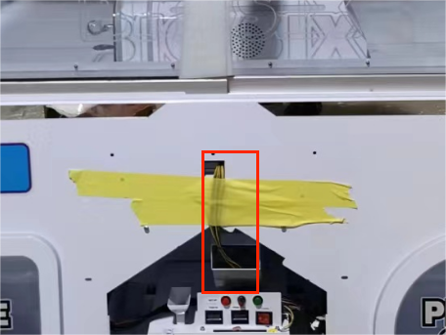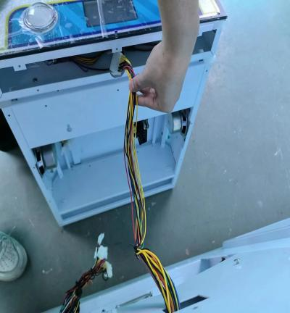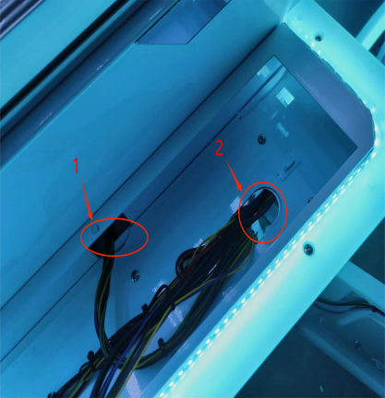
- Tighten the console screws, a total of 11 screws

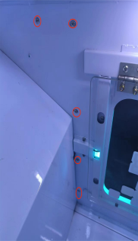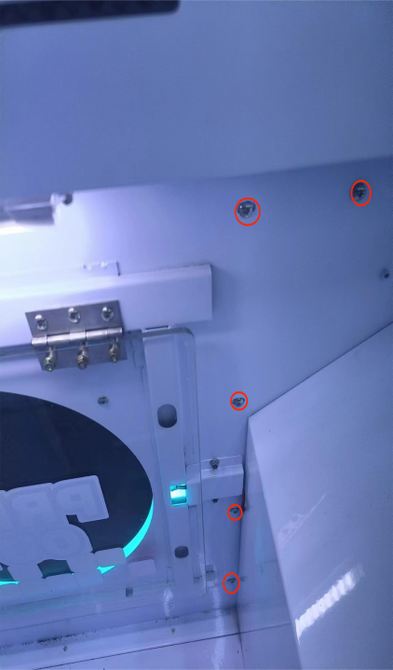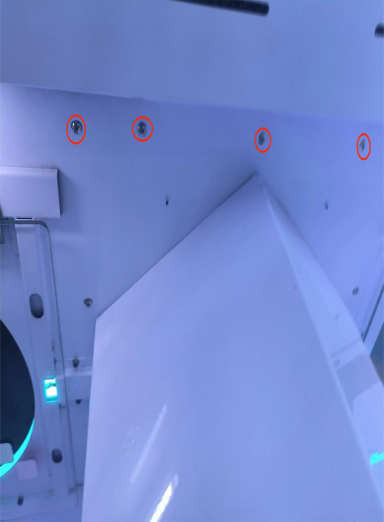
Note:
- . Before installing the console, you can also first fix two screws in the two pulley holes at the front of the console, and then tighten the screws on the back of the console.
- Before removing the console, you can also first fix two screws in the two pulley holes at the front of the console (no need to tighten completely, just leave about 1/3 of the screws outside), and then remove the screws on the back of the console. After removal, slightly lift the console to easily remove it.

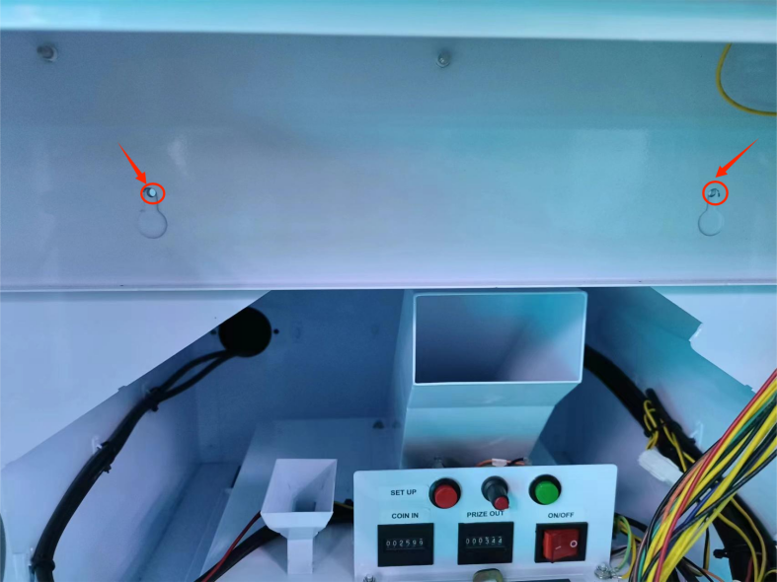

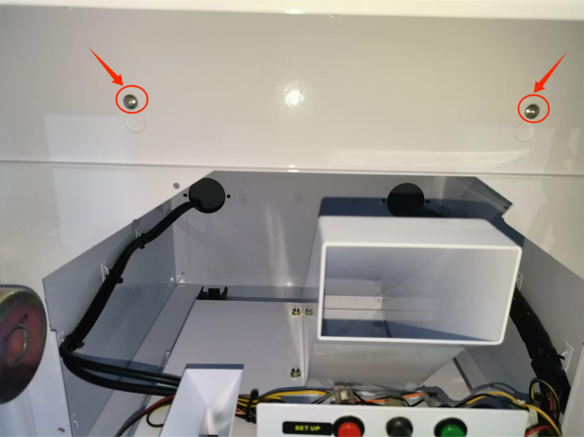
4.Tighten the console hardware color plate (there is hardware at the bottom of the color plate), a total of 6 screws.

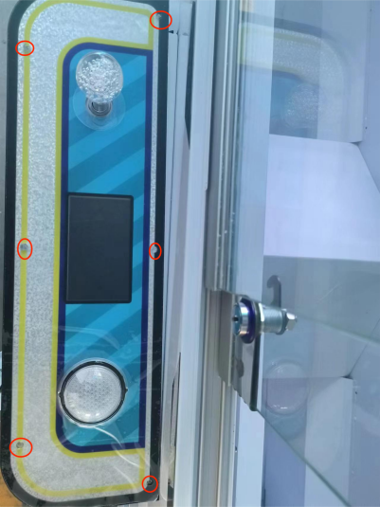

5.Remove the two screws under the cash box, move the cash box to the outermost side, and tighten the two screws under the cash box again.

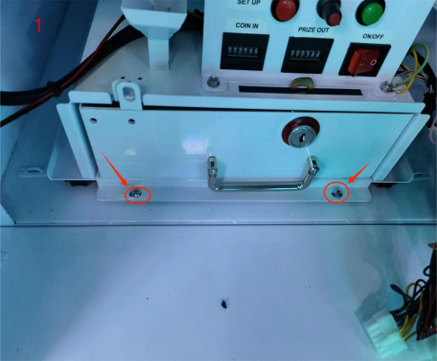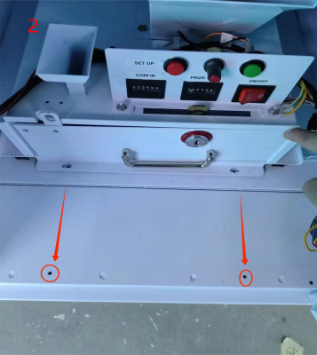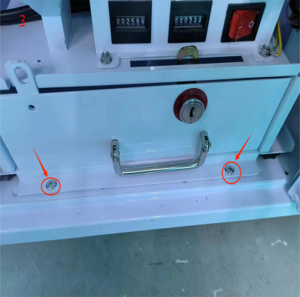
6. Connect each connector

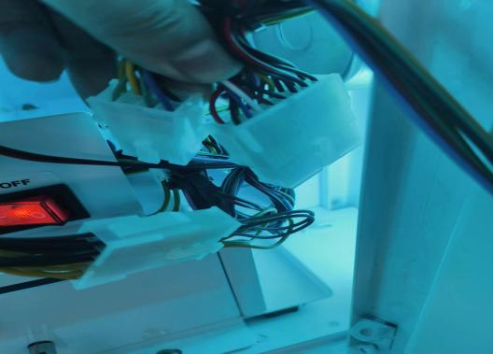

11. Wiring Diagram

