Pistol Hardware Kit and Locations – Version 1.3
(QS/BS-03-450-C)

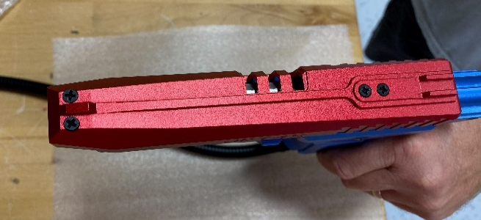
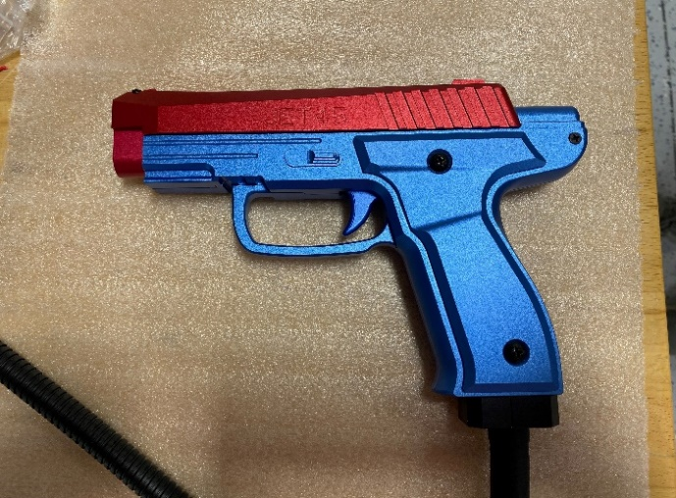
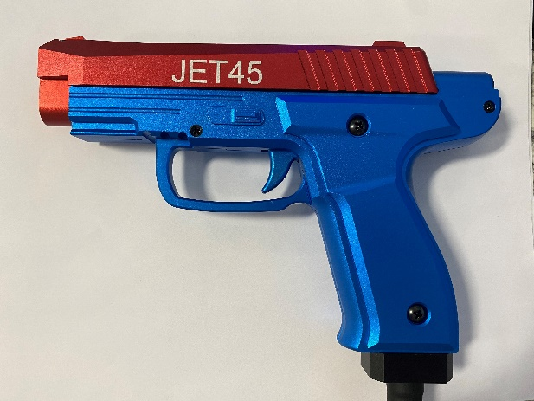
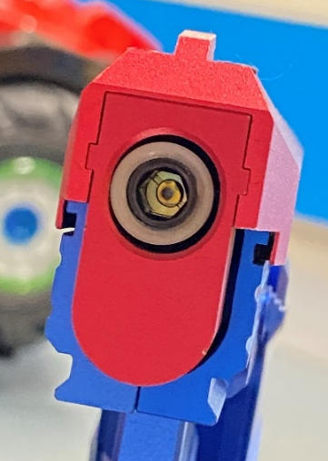
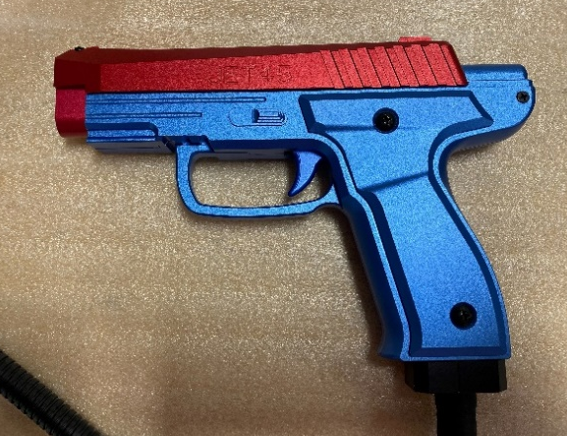
4&10
3&10
5&10*
2

1
9
7
6
5

 | Part Number | Location  Description | Gun Needs | Kit Includes
1 | QS-03-226 | Gun Handle Screw – Left – M4x6 – Cross Round Head | Qty 2 | Qty 6
2 | QS-03-227 | Gun Butt Screw – Left - M3x6 – Cross CS Head | Qty 1 | Qty 3
3 | QS-03-218-B | Gun Front Head Screw – M4x12 | Qty 2 | Qty 6
4 | QS-03-220 | Gun Slide Screw – M3x10 – Cross CS Head | Qty 1 | Qty 3
5 | QS-03-228 | Gun Butt/Slide Screw – Right – M3x16 – Cross CS Head | Qty 2 | Qty 6
6 | QS-03-219 | Gun Handle Screw – Right – M4x20 – Cross Round Head | Qty 2 | Qty 6
7 | QS-03-217 | Gun Tube Screw – M8x6 | Qty 1 | Qty 2
8 | QS-03-221 | Lock Washer – M3 | Qty 5 | Qty 15
9 | QS-03-229 | Gun Body Front Screw – M3x12 | Qty 1 | Qty 3
10 | QS-03-221-B | Lock Washer – M4 | Qty 2 | Qty 6

