Changing Language in Big Shot

- Enter into the Setting Mune in the game by pressing the Green button inside the front cabinet.
- Enter into the “Systems” menu ( Top option )
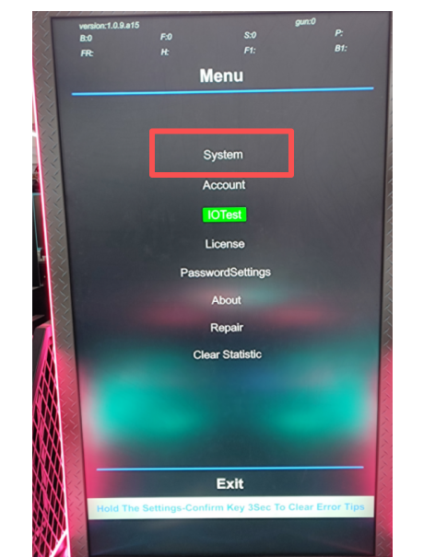
- In the Systems Menu select “Basic” menu ( Top Option again)
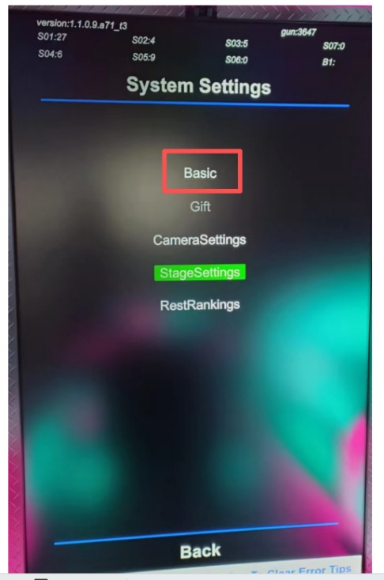

- In the Basic Menu Select Language menu ( 4th option from the top)
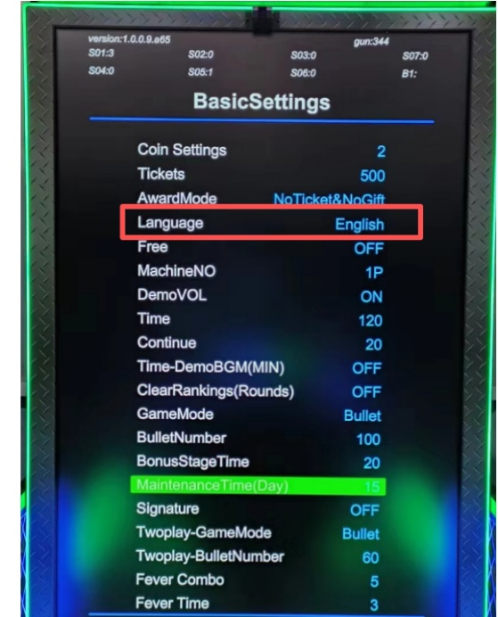

- Game will ask for a passcode. Code is 3718 and “OK”
- If unit is in Chinese, T he Chinese Character for “English” is circled below
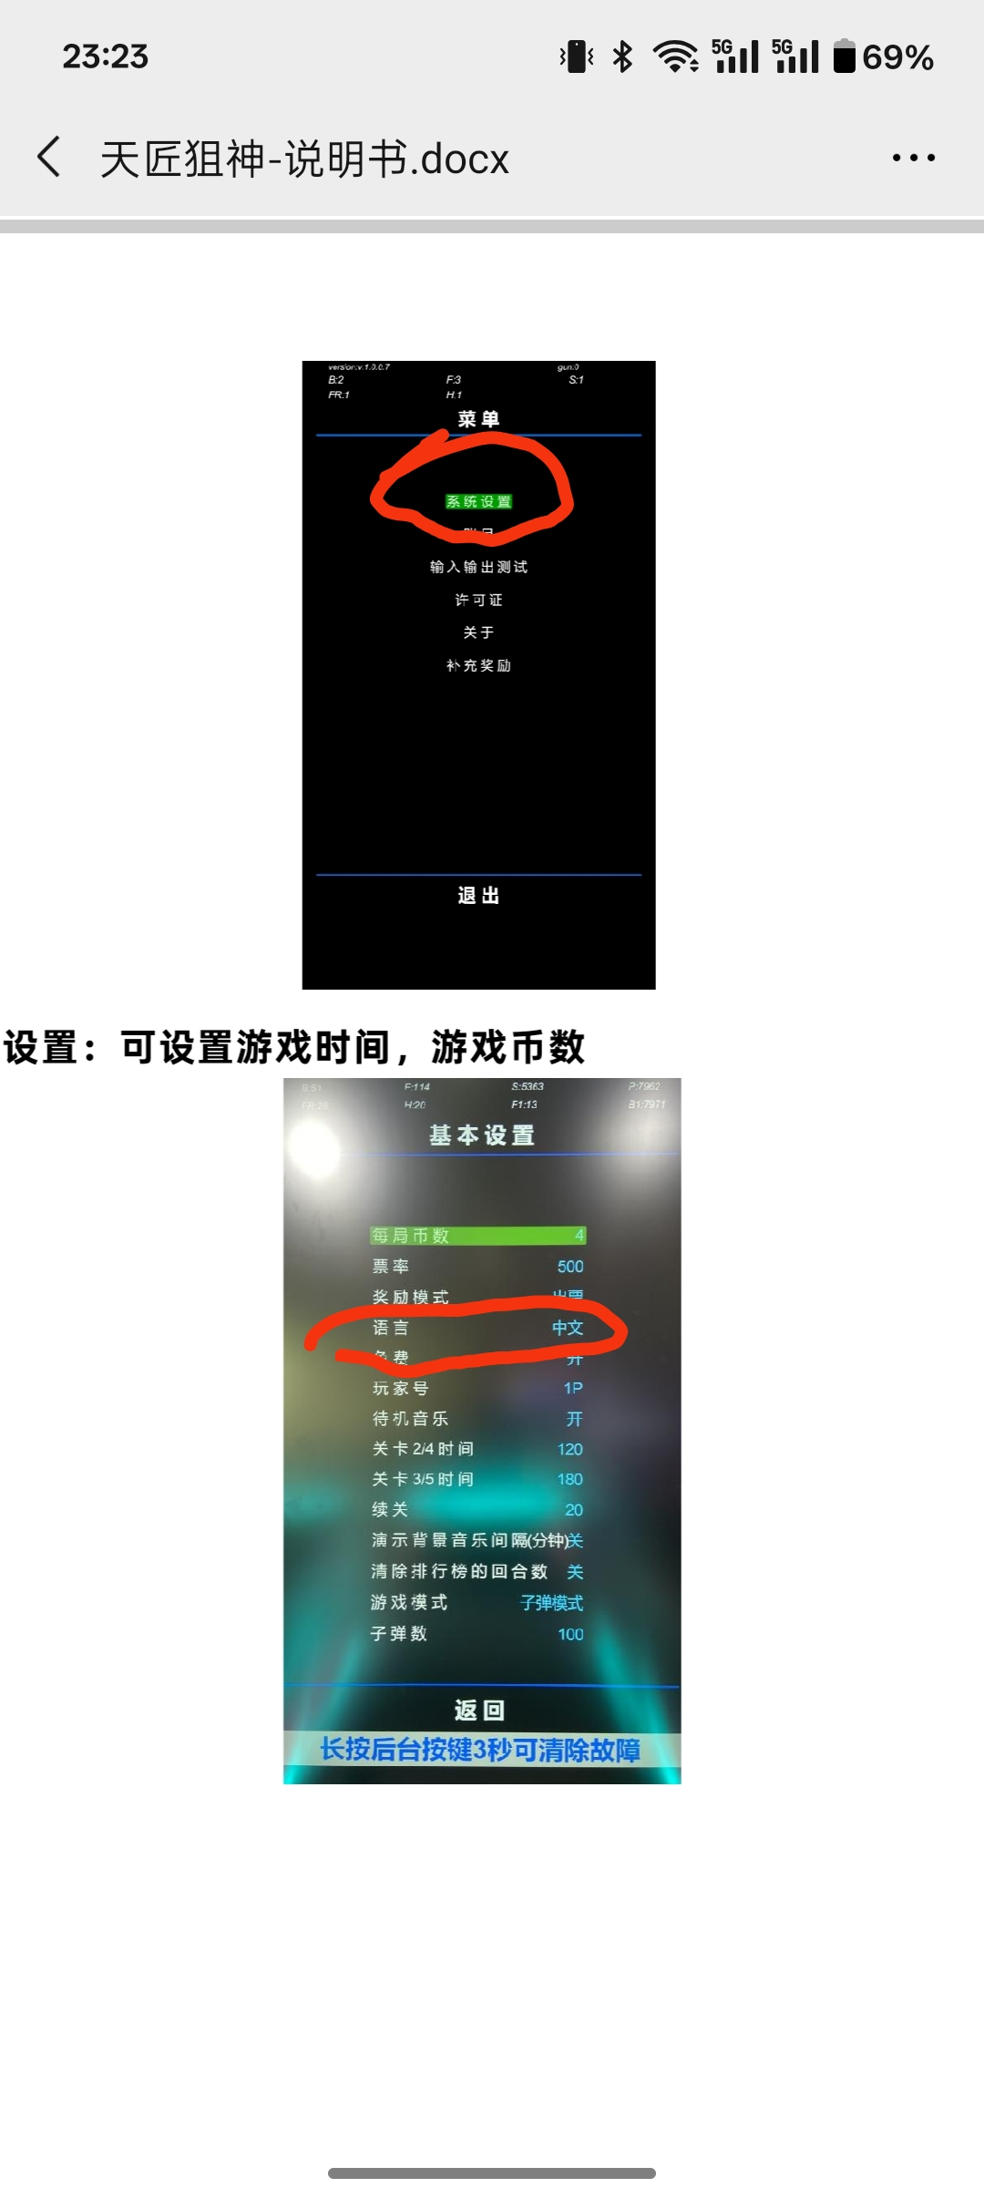
- Once the Language is selected enter the passcode as in the attached picture below and select the lower left box (“OK”) to confirm.

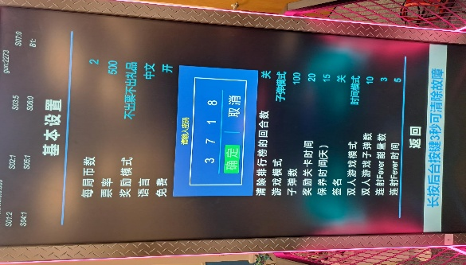
- Go to the Bottom of each page and click the “Exit” tap at the bottom middle and you will see an exit and safe message in Chinese. Click the selection button as in the picture below. Continue to do this an confirm the changes on the 3 screen until you are all the way out of the settings menu and back into the game. It will them be in English once settings menu is exited fully
