Gun Hardware Kit and Locations –
Version 1.2
(QS/BS-03-450-B)

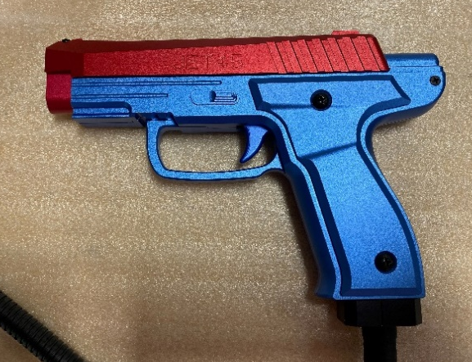
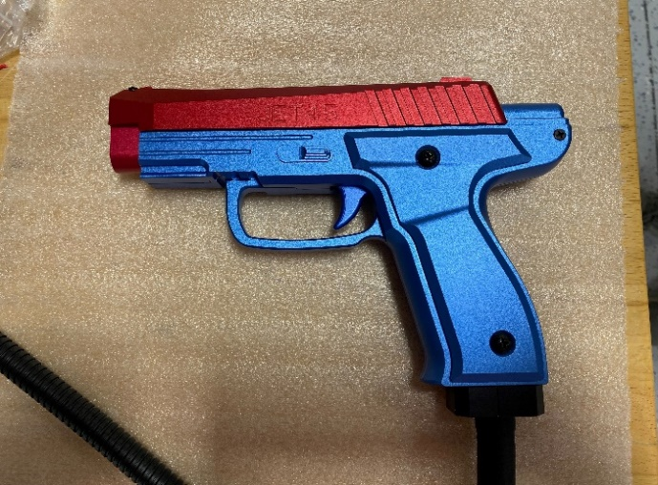
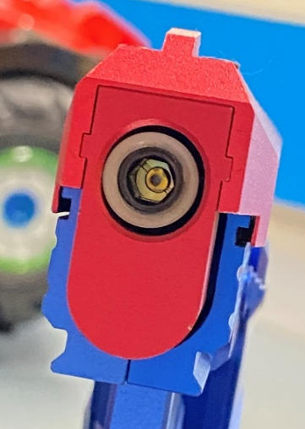
6
5

2

1
7
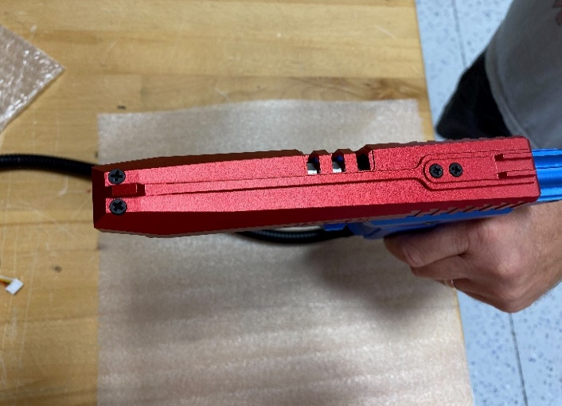
4&8
3&8
5&8

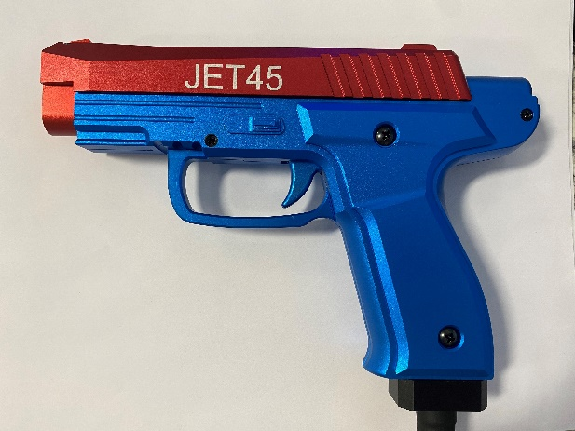
9

 | Part Number | Location  Description | Gun Needs | Kit Includes
1 | QS-03-226 | Gun Handle Screw – Left – M4x6 – Cross Round Head | 2 | 6
2 | QS-03-227 | Gun Butt Screw – Left - M3x6 – Cross CS Head | 1 | 3
3 | QS-03-218 | Gun Front Head Screw – M3x10 | 2 | 6
4 | QS-03-220 | Gun Slide Screw – M3x10 – Cross CS Head | 1 | 3
5 | QS-03-228 | Gun Butt Slide Screw – Right – M3x16 – Cross CS Head | 1 | 3
6 | QS-03-219 | Gun Handle Screw – Right – M4x20 – Cross Round Head | 2 | 6
7 | QS-03-217 | Gun Tube Screw – M8x6 | 1 | 2
8 | QS-03-221 | Lock Washer – M3 | 5 | 15
9 | QS-03-229 | Gun Body Front Screw – M3x12 | 1 | 3

